THE LONG RETURN

Food Has to Get Here
  - Food Distribution, Distance, and Resilience in Pit River Country
Public Community Briefing
Version 0.2.3 · Public Working Briefing
Issue date: August 20, 2026
Facts and current program status checked: August 20, 2026
The question is not only whether food exists. The question is whether the system can still get it to people when something changes.
Christopher Knorr | The Long Return
Independent civic work - not an official Pit River Tribe publication or notice.

Why this briefing exists
Some Pit River Tribal members have raised concerns about food distribution and logistics. This briefing asks a simple public question: if one part of the food system is disrupted, what helps food continue to reach people across a large rural geography?
The question includes the Pit River Greenhouse Project and related work because recent Tribal publications connect greenhouse development with food sovereignty, reliable year-round production, and reducing dependence on vulnerable outside food-supply chains.

What this briefing finds
MAIN FINDING: The public sources reviewed support treating food access as a network question, not a greenhouse-only question. Production matters, but so do storage, transportation, distribution, information, backup supply, and the final trip home.
- Food access depends on the whole chain. Production alone does not guarantee household access.
- USDA reported the immediate 2024 FDPIR delivery disruption resolved, but the episode showed how concentrated logistics can expose communities when a key warehouse or route fails. [R14]
- Greenhouse redevelopment activity is documented, but current edible-production scale and household distribution at scale are not established in the public sources reviewed.
- A first Humisoil batch is a documented physical output. The expected support for more than 100,000 plants remains prospective. [R1]
- The Tribe identifies reliable year-round production and reduced dependence on vulnerable external food supply chains as objectives of proposed greenhouse improvements; the same notice says those SGC projects are not yet funded or confirmed. [R1]
- The public sources reviewed do not provide enough current-state detail to identify one major logistics investment as the best choice. A useful comparison would first clarify what capacity already exists, where the gap is, what an option would cost to keep operating, and what improvement in reliability it is expected to produce.
What this means now. This briefing does not call the greenhouse a success or a failure. It separates documented implementation from outcomes that remain prospective or are not established in the public sources reviewed.
Independent civic work. This briefing does not speak for the Pit River Tribe, any Tribal department, family, elder, government or institution. The full source, authority, privacy and correction rules are in the appendices.

Contents
1. Food access depends on the whole chain
2. Rural distance can make disruption harder to absorb
3. The 2024 FDPIR disruption shows why backup capacity matters
4. Regional food-security data is context - not a Pit River household rate
5. Greenhouse redevelopment is documented; current edible-production scale is not
6. A first Humisoil batch is a documented physical output
7. Public sources tell us more about implementation than community outcomes
8. Food resilience can be approached through three questions
9. Several related projects and capacities could form a larger network
10. Important current questions remain unanswered in the public sources reviewed
11. A current-state picture would make infrastructure comparisons more useful
12. Before comparing major investments, count the full operating requirements
Conclusion - the public picture is stronger, but still incomplete
- Appendix A - Evidence method and source hierarchy
- Appendix B - Projection-to-Reality ledger
- Appendix C - Current Reality Information Audit
- Appendix D - Outcome and measurement framework
- Appendix E - Capital and resilience investment screen
- Appendix F - Detailed decision checks
- Appendix G - Program and policy watch
- Appendix H - Figure register and evidence status
- Appendix I - Source-control, corrections and standing review trigger
- Appendix J - Current bottom-line findings
- References

1. Food access depends on the whole chain
Food access depends on more than whether food exists somewhere in the system. For a geographically dispersed community, food may have to move through purchasing, warehouses, transportation, roads, schedules, storage, refrigeration, local distribution, information, and the final trip home. A greenhouse or warehouse can contain food while a household still cannot reliably receive it.
MAIN FINDING: The public sources reviewed support treating food access as a network question, not a greenhouse-only question. Production matters, but so do storage, transportation, distribution, information, backup supply, and the final trip home.
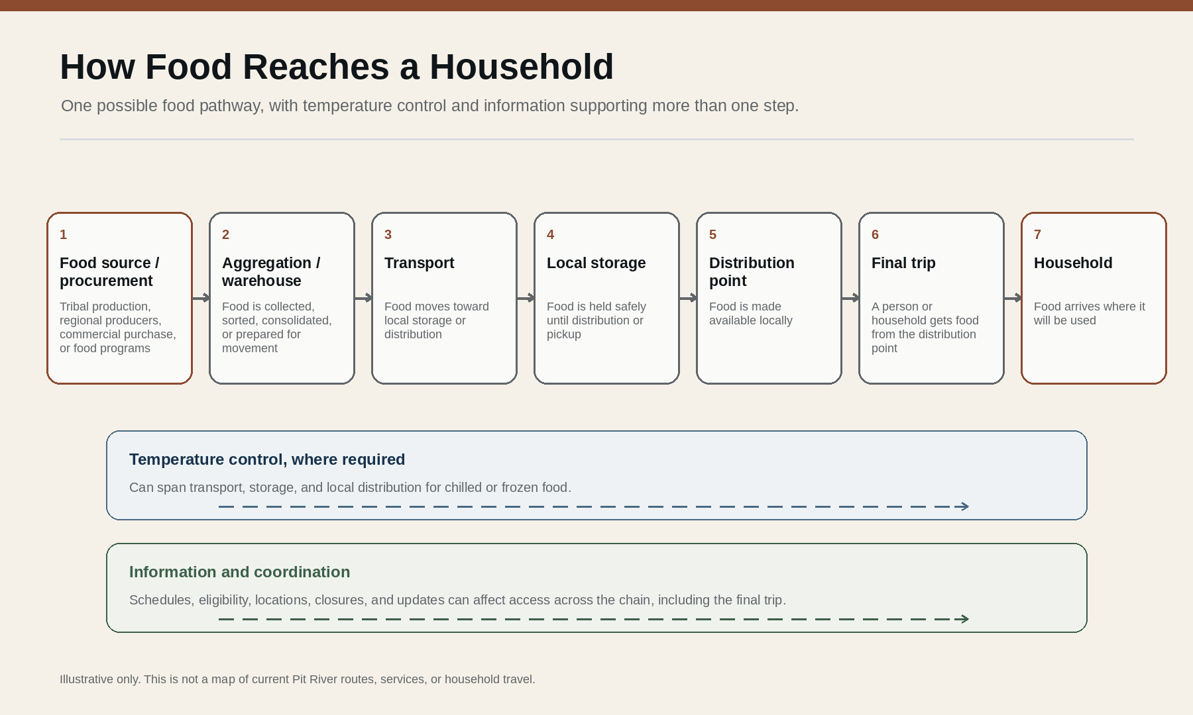
Figure 1. How Food Reaches a Household. Food moves through several physical steps, while temperature control and information can support more than one part of the chain. Illustrative only; not a map of current Pit River routes, services, or household travel.

2. Rural distance can make disruption harder to absorb
Pit River ancestral territory spans a large geography across parts of Shasta, Siskiyou, Modoc and Lassen Counties. [R3] In rural areas, routes are longer, destination volumes can be smaller, replacement supply may be farther away, and chilled or frozen foods require continuous temperature control.
Regional food-hub research identifies routing, reliable pickup and delivery schedules, transportation partnerships, anchor buyers and efficient use of physical assets as recurring rural logistics concerns. [R20] Food-supply-chain research likewise emphasizes roads, safe storage, affordable transportation and temperature-controlled distribution. [R21]
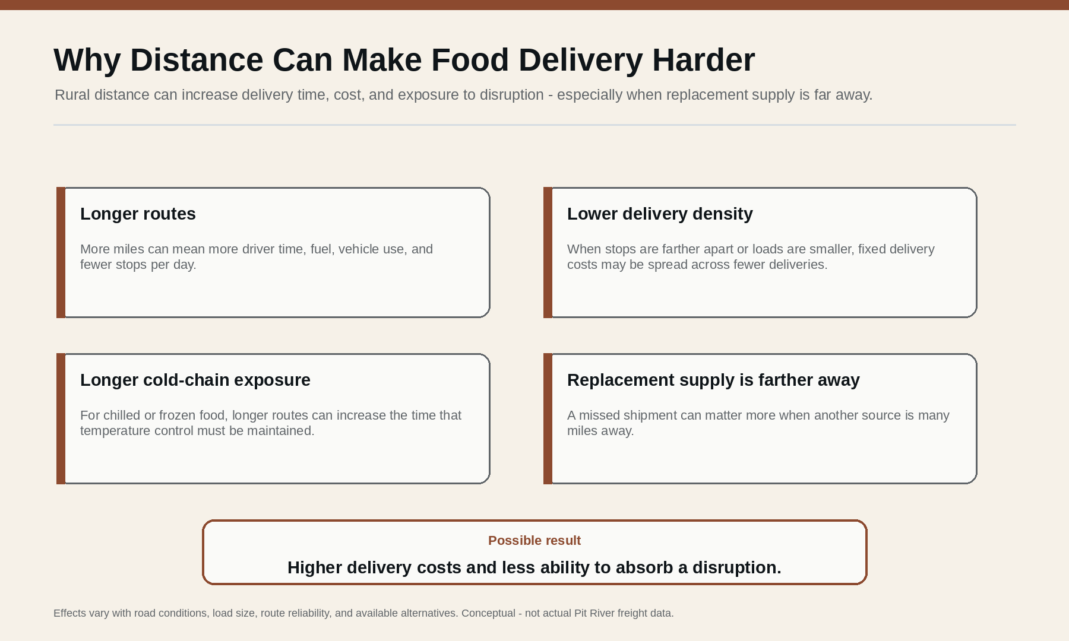
Figure 2. Why Distance Can Make Food Delivery Harder. Longer routes, lower delivery density, longer cold-chain exposure, and distant replacement supply can increase delivery cost and disruption exposure. Conceptual; not actual Pit River freight data.

3. The 2024 FDPIR disruption shows why backup capacity matters
In 2024, USDA reported major supply-chain disruptions affecting the Food Distribution Program on Indian Reservations (FDPIR) and the Commodity Supplemental Food Program. USDA said delays stemmed from disruptions at a contracted national warehouse and affected inventory and the quantity and variety of foods available at program sites. By October 28, 2024, USDA reported that contractor deliveries had returned to regularly scheduled delivery dates after emergency measures and added warehouse capacity. [R14]
USDA reported the immediate 2024 delivery disruption resolved. The lasting lesson is narrower: a food system can work normally and still be exposed when too much depends on a small number of places or routes.

4. Regional food-security data is context - not a Pit River household rate
County-level food-insecurity estimates help describe the surrounding region, but they do not establish a Pit River-specific household rate. [R26] A Klamath Basin study provides important Indigenous regional context but studied households associated with the Karuk, Yurok, Hoopa and Klamath Tribes, not Pit River households. [R23]
This briefing uses regional food-security research as context only. It does not convert those figures into a Pit River statistic.

5. Greenhouse redevelopment is documented; current edible-production scale is not
Public sources reviewed for this briefing document greenhouse restoration after years of dormancy, grants, staffing, workforce development and continuing project activity. [R2] [R8] [R10] [R11] [R13]
The Tribe's August 2026 Quarter 3 newsletter describes proposed improvements to the 10-acre greenhouse on the XL Ranch Reservation: solar energy, improved HVAC climate controls and water infrastructure intended to support reliable year-round food production and reduce dependence on vulnerable external food supply chains. The same notice states that these SGC projects are proposals and are not yet funded or confirmed. [R1]
THE GREENHOUSE IS PART OF A LARGER NETWORK. The public sources reviewed support treating it as one potentially important production component connected to storage, transportation, food programs, regional suppliers and households.

6. A first Humisoil batch is a documented physical output
The August 2026 Tribal newsletter reports that the Humisoil Production Project is nearing completion and that the Tribe has produced its first batch using invasive juniper and other organic material. After a six-month curing process, the Tribe expects the material to support more than 100,000 native plants for greenhouse and food-sovereignty projects. [R1]
Those are different evidence states: the first Humisoil batch is documented; the more-than-100,000-plant figure remains an expected next output until later production is reported.

7. Public sources tell us more about implementation than community outcomes
The public sources reviewed provide substantial information about physical infrastructure, grants, staffing, training, equipment, planning, revitalization, partnership development, native-plant work and Humisoil production.
They provide much less information about edible pounds harvested, pounds distributed to members, households reached, recurring distribution frequency, winter production, cold-storage capacity, food-distribution transportation, permanent FTEs, earned revenue, operating cost and measured reduction in outside food dependence.
Unknown is not zero. Unreported does not mean unaccomplished. An unanswered question limits the conclusion; it does not become a finding against the project.

8. Food resilience can be approached through three questions
Immediate continuity means keeping current food programs, emergency resources, contacts, eligibility and alternatives visible. Pit River Social Services already provides a public doorway for assistance information; time-sensitive availability and eligibility should still be confirmed with the responsible program. [R4]
Operational resilience means understanding the physical chain: sources, routes, storage, refrigeration, transportation, schedules, inventory visibility, replacement supply and failure points.
For the limited purpose of this briefing, one longer-term question is where greater Tribal control over production, procurement or distribution could strengthen reliability and community benefit. USDA's FDPIR Self-Determination Demonstration provides one federal example in which selected Tribal organizations can choose vendors and procure certain foods themselves. [R15] [R16] This is not a complete definition of food sovereignty or a statement of Pit River Tribal policy.
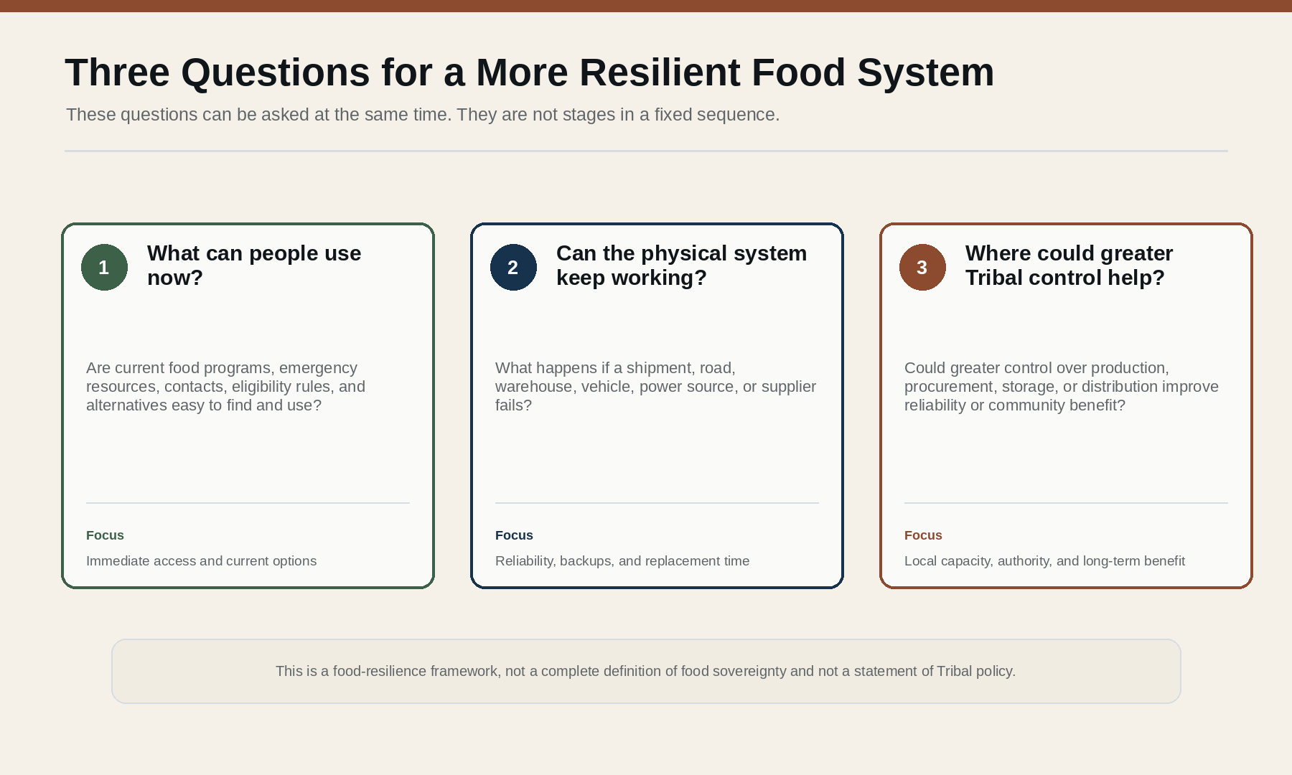
Figure 3. Three Questions for a More Resilient Food System. Three parallel questions about current access, physical reliability, and where greater Tribal control could help. This is not a complete definition of food sovereignty or a statement of Tribal policy.

9. Several related projects and capacities could form a larger network
Public sources point to several documented or proposed pieces: land stewardship and juniper work, Humisoil, greenhouse and native-plant work, food programs, regional suppliers, and energy and water planning. Storage and food-distribution transportation are also important parts of a food system, but their current Pit River capacity is not established in the public sources reviewed.
Some relationships are documented, some are developing, and others remain proposed or not publicly established. The figure uses line style and labels rather than color alone to preserve those distinctions.
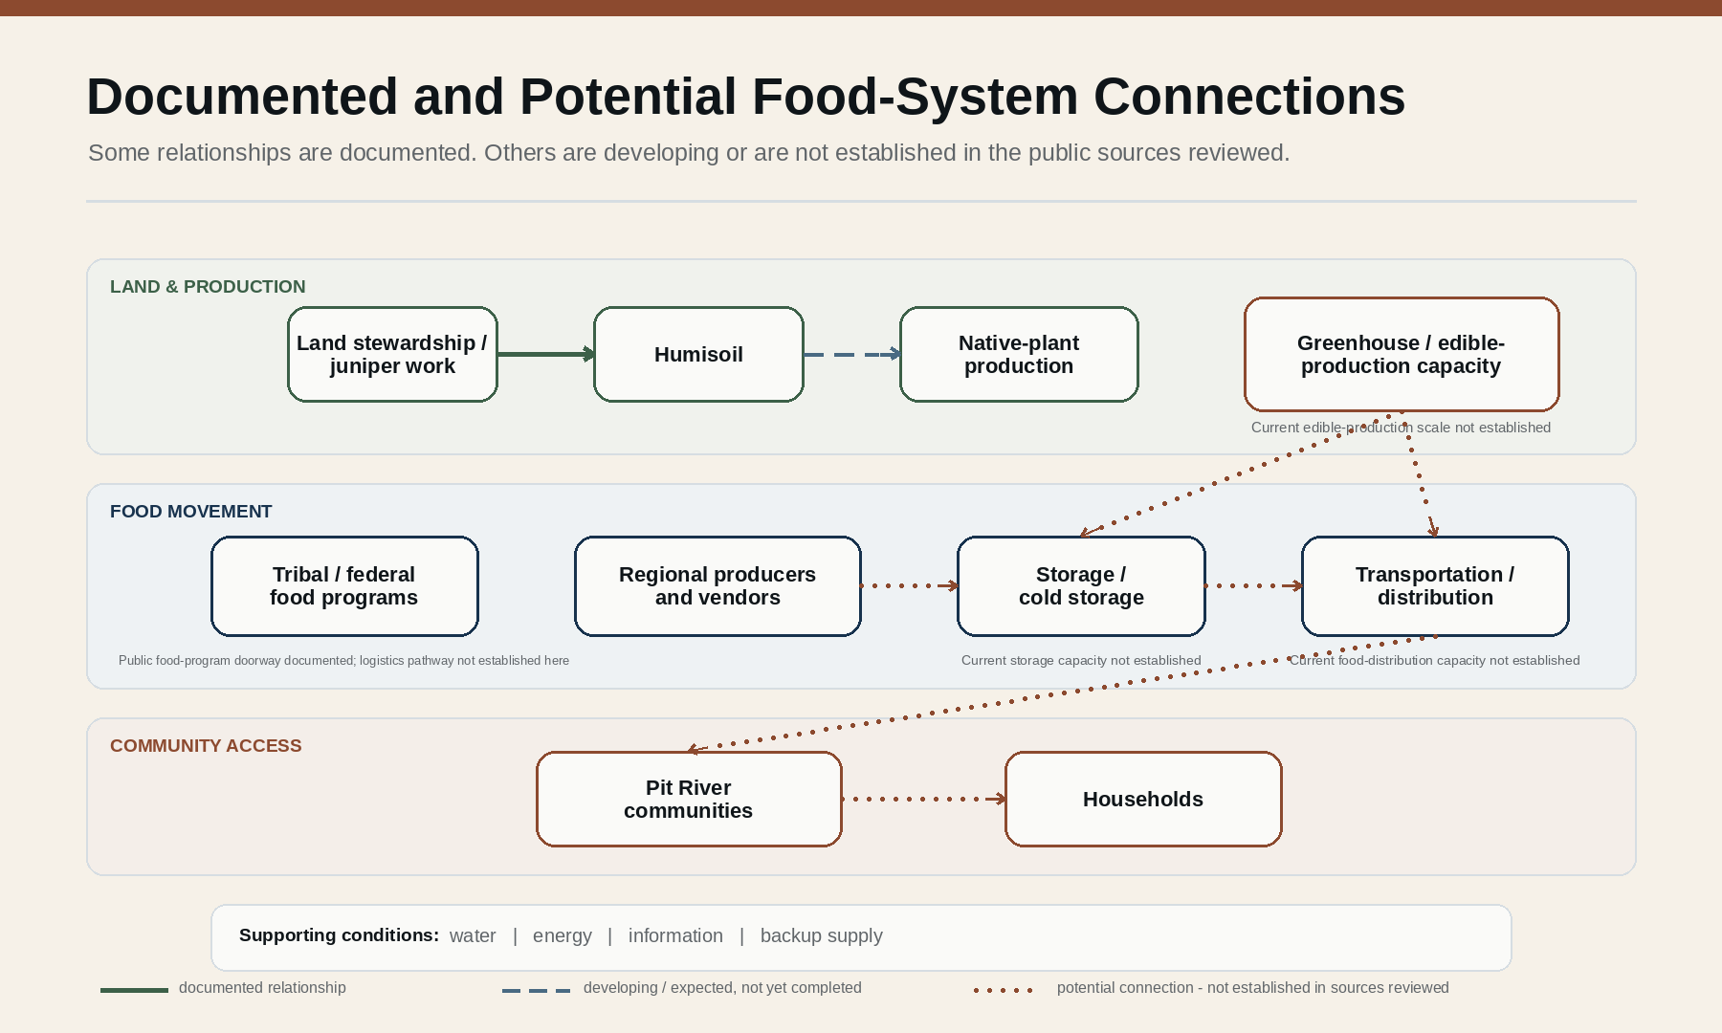
Figure 4. Documented and Potential Food-System Connections. A bounded network view separating documented relationships, developing or expected relationships, and potential connections not established in the public sources reviewed.

10. Important current questions remain unanswered in the public sources reviewed
The Current Reality Information Audit groups 25 questions that would help distinguish project activity from demonstrated outcome. The public briefing does not need private household information or sensitive operational details to identify where the public picture remains incomplete.
WHAT THE PUBLIC SOURCES STILL DO NOT TELL US: how much edible food is being produced; how much reaches members and how regularly; whether edible production continues through winter; what storage and food-distribution transportation capacity already exists; which jobs are permanent; what recurring costs or revenues exist; and what measurable change would count as reduced dependence on outside supply chains.
In this briefing, “not publicly established” means only that the public sources reviewed do not provide enough information to verify the point. It does not mean the activity did not occur or that the information does not exist.

11. A current-state picture would make infrastructure comparisons more useful
The public sources reviewed do not provide enough current-state detail to compare major logistics investments responsibly. A public-facing current-state picture could identify, at an appropriate and non-sensitive level, current food sources, service areas, greenhouse production, dry/chilled/frozen storage, transportation, distribution points, backup suppliers, emergency purchasing mechanisms, regional partners and places where one failure could interrupt service.
If such a map already exists internally, this briefing does not establish that. The point is narrower: public analysis should not assume a missing truck, freezer, warehouse or other asset before the existing system and its gaps are understood.

12. Before comparing major investments, count the full operating requirements
The public sources reviewed are not sufficient to identify one major logistics investment as the best choice. Before comparing options, it is useful to separate one-time purchase or construction cost from ongoing staffing, utilities, fuel, insurance, maintenance, replacement, funding continuity and other dependencies. [R30]
That matters for cold storage, vehicles, processing equipment, expanded greenhouse systems or a new facility. A useful comparison asks what problem an option addresses, what it requires to keep operating, and what measurable improvement in reliability it is expected to produce.
The detailed investment screen, organizational checks and evidence rules are kept in the appendices so the public briefing can stay focused on the food-system question.

Conclusion - the public picture is stronger, but still incomplete
Public sources reviewed for this briefing document continuing implementation: greenhouse revitalization, staffing and training, grants and partnerships, Humisoil integration, a first documented Humisoil batch, and proposed energy, water and climate-control improvements.
They provide much less information about current edible production, distribution reach, year-round operation, storage, transportation, operating cost and measurable reduction in outside dependence. That leaves the public picture incomplete, not negative.
Implementation is documented. Some intermediate outputs are documented. Several food-access, economic and resilience outcomes remain prospective or are not established in the public sources reviewed.
For the limited purpose of this briefing, food sovereignty is relevant where greater Tribal control over production, procurement or distribution could strengthen reliability. That is not a complete definition of food sovereignty for the Pit River Tribe or any Tribal community.
Food has to get here. A stronger system is one that has more than one way to keep food moving when the usual route is disrupted.

Appendix A - Evidence Method and Source Hierarchy
Purpose: determine what the public sources reviewed for this briefing establish, what was projected, what is underway, what remains unknown, and what cannot responsibly be concluded. This is not an audit of internal Tribal government operations and does not presume a right to obtain nonpublic information.

Source hierarchy
- Level 1 - current official Pit River Tribe publications, pages, public RFPs and authorized project communications.
- Level 2 - current government grant, program, legislative and regulatory records.
- Level 3 - current official funder or project-partner records.
- Level 4 - peer-reviewed or professional research used for general logistics, resilience and food-system context.
- Level 5 - interpretation, which must remain narrower than the evidence above.

Evidence-status vocabulary
VERIFIED CURRENT: A current source directly establishes the claim.
PARTIALLY VERIFIED: Some parts are documented, but a material variable remains unresolved.
HISTORICAL / PRIOR STATE: Evidence describes an earlier condition and is not silently treated as current.
FUNDED / UNDERWAY: Funding or implementation activity is documented.
OUTPUT DOCUMENTED: Something tangible has actually been produced, hired, constructed, delivered or completed.
OUTCOME DEMONSTRATED: Evidence shows the underlying objective produced a measurable result.
PROJECTED: The source describes an intended future result.
PROPOSED / FUNDING PENDING: A project or improvement is under consideration but is not yet established as funded and implemented.
CONFLICTING / NOT COMPARABLE: Sources differ materially or use definitions that cannot responsibly be combined.
NOT PUBLICLY ESTABLISHED: The public sources reviewed for this briefing do not provide enough information to verify the point. This does not mean the activity did not occur or that the information does not exist.
NOT APPROPRIATE FOR PUBLIC DISCLOSURE: The information may exist but should not be sought or published at the requested level because of privacy, security, cultural, operational or other legitimate boundaries.
Unknown is not zero. Unreported does not mean unaccomplished. Proposed does not mean funded. Funded does not mean completed. Activity does not by itself demonstrate outcome.

Appendix B - Projection-to-Reality Ledger
This ledger preserves the sequence between earlier public expectations, current public evidence and the bounded v0.2.3 disposition. It is designed to prevent a projection from silently becoming an accomplishment.
Area | Earlier expectation / projection | Current public evidence | v0.2.3 disposition
Greenhouse physical complex | Earlier sources describe a substantial four-season facility, 44 hoop houses and a 10-acre growing operation. [R9] | The Tribe later described restoration after years of dormancy and the 10-acre greenhouse site. [R2] | Physical asset documented; current usable/active capacity not publicly established.
Food production | Food production for Tribal members was an explicit project objective. [R9] | Redevelopment and intended production are documented, but no current harvest total was located. | Implementation documented; production volume unknown.
Free food for members | Free produce for Tribal members was described as a project objective. [R9] | No aggregate pounds or distribution totals were located. | Projected objective; current outcome not publicly established.
Year-round production | Earlier sources envisioned four-season / year-round growing. [R9] [R13] | Aug. 2026 proposal seeks solar, HVAC and water improvements to support reliable year-round production. [R1] | Reliable year-round production remains an objective, not a verified current condition.
Reduced external dependence | Food sovereignty framing emphasized less reliance on distant supply chains. [R9] | The Aug. 2026 Tribal proposal expressly states reduced dependence on vulnerable external supply chains as an objective. [R1] | Objective verified; actual reduction not publicly measured.
Humisoil | Catalyst project proposed converting invasive juniper biomass into Humisoil. [R12] | The Tribe reports the first batch has been produced and the project is nearing completion. [R1] | Physical output documented.
100,000+ plants | Humisoil intended to support greenhouse/native-plant and food-sovereignty work. | The Tribe expects cured Humisoil to support more than 100,000 native plants. [R1] | Expected next output; not yet counted as achieved.
Employment | First Nations projected 10-20 full-time positions. [R9] | CalOSBA reported 25 jobs supported and plans for at least 35; public postings show some roles are temporary/grant-funded. [R6] [R7] [R13] | Employment activity documented; figures not comparable enough to establish permanent FTE performance.
Training | Workforce development was an explicit objective. [R9] | Training/apprenticeship and project roles are documented. [R8] | Activity verified; aggregate completion/credential count unknown.
Solar / energy resilience | Solar, geothermal and energy sovereignty appeared in earlier plans. [R5] [R9] | Solar remains part of the Aug. 2026 proposed greenhouse improvement package. [R1] | Energy-resilience planning documented; greenhouse energy independence not established.
Economic revenue | Surplus produce, nursery and restoration revenue were envisioned. [R9] | Regional market intentions are described, but no greenhouse revenue total was located. [R13] | Revenue outcome not publicly established.
Regional network | Earlier accounts envisioned regional market and partner relationships. [R9] [R13] | Partnership-development staffing is documented. [R6] | Network-building underway; operating food flows not yet measurable from public sources.
TCC greenhouse resilience | Solar, HVAC and water upgrades are intended to improve year-round reliability and reduce outside dependence. [R1] | The Tribe states the proposal is not yet funded or confirmed; TCC Round 6 is still application-stage. [R1] [R18] | Prospective only.
Community Resilience Center | Approx. $10 million center proposed for emergency and community resilience. [R1] | The Tribe states the proposal is not yet funded or confirmed; CRC Round 2 is application-stage. [R1] [R19] | Proposal only; not existing food infrastructure.

Appendix C - Current Reality Information Audit
Tier 1 questions are publication-critical; Tier 2 questions are decision-critical; Tier 3 questions provide additional contextual measurement. An unanswered question blocks the corresponding conclusion - it does not become a negative finding.
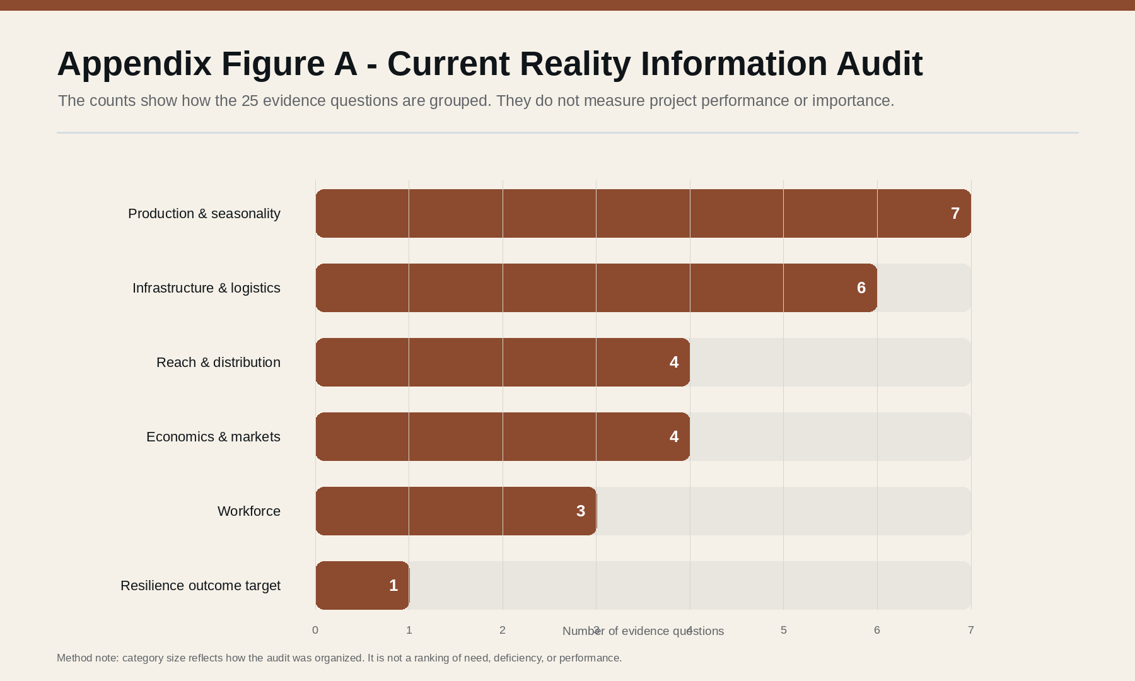
Appendix Figure A. Current Reality Information Audit. The 25 evidence questions grouped by domain. Counts show how the audit is organized, not project performance, importance, or deficiency.
# | Current-reality question | Triage | Current public status | Effect on briefing
1 | How many greenhouse/hoop-house structures are currently usable? | Tier 1 | Not publicly established | Do not equate historical facility count with current usable capacity.
2 | How many are presently in active cultivation? | Tier 1 | Not publicly established | Do not claim the entire complex is operating.
3 | How many acres or square feet are actually under production? | Tier 1 | Not publicly established | The 10-acre site is not the same thing as 10 acres under cultivation.
4 | What edible foods were grown in 2025 and 2026? | Tier 1 | Partially established | Do not convert intended crop categories into a verified harvest record.
5 | Approximately how many pounds were harvested? | Tier 1 | Not publicly established | No production-at-scale claim.
6 | How much was distributed free to Tribal members? | Tier 1 | Not publicly established | Free distribution remains an objective rather than a measured result.
7 | Approximately how many households or members received food? | Tier 1 | Not publicly established | No claim of broad household reach.
8 | Which communities received it? | Tier 2 | Not publicly established | Geographic reach remains open; any public measure should remain aggregated.
9 | Is distribution recurring, seasonal or pilot-scale? | Tier 1 | Not publicly established | Do not describe a recurring distribution system without evidence.
10 | What percentage of greenhouse activity is edible food versus native/restoration plants? | Tier 2 | Not publicly established | Food and restoration outputs should not be combined as one production measure.
11 | Does the facility presently produce through winter? | Tier 1 | Not publicly established | Treat reliable year-round production as an objective.
12 | What heating, cooling, water and backup-power systems currently operate? | Tier 2 | Partially established | Proposed upgrades identify relevant needs but not the complete current baseline.
13 | What cold-storage capacity exists? | Tier 1 | Not publicly established | Cold-chain adequacy cannot presently be evaluated.
14 | What dry-storage capacity exists? | Tier 2 | Not publicly established | Storage adequacy remains unknown.
15 | What trucks or other transportation assets are available? | Tier 1 | Not publicly established for food distribution | Do not infer food-logistics capacity from general vehicle assets.
16 | How many project jobs are permanent FTEs? | Tier 2 | Not publicly established | Do not interpret jobs supported as permanent FTEs.
17 | How many are temporary, grant-funded, trainee, fellow or contractor positions? | Tier 2 | Partially established | At least some roles are explicitly temporary/grant-funded.
18 | How many Tribal members have completed training or earned credentials? | Tier 3 | Not publicly established | Training activity can be described; aggregate outcome cannot.
19 | Has the greenhouse generated earned revenue? | Tier 2 | Not publicly established | Do not make a financial-sustainability claim.
20 | Have restoration or nursery contracts actually been executed? | Tier 2 | Not publicly established | Planned contracts/markets remain distinct from executed work.
21 | Has produce been sold through Modoc Harvest or another market? | Tier 2 | Not publicly established | Market intention should not be reported as recurring sales.
22 | What is the current cost of operating the greenhouse? | Tier 2 | Not publicly established | Grants and asset value cannot substitute for operating cost.
23 | What are the current largest operating constraints? | Tier 1 | Partially indicated, not ranked | Energy, HVAC and water appear important; do not declare them the largest constraints without assessment.
24 | What parts of the TCC greenhouse proposal replace absent infrastructure versus upgrade existing infrastructure? | Tier 1 | Not publicly established | Needed before interpreting the capital proposal against current reality.
25 | What measurable target would constitute reduced dependence on vulnerable external food supply chains? | Tier 1 | Not publicly established | The objective is verified; achievement cannot be measured without a baseline and target.

Privacy and disclosure boundary
A public assessment does not require household names, addresses, individual benefit status, exact security-sensitive facility information, private inventories, internal emergency procedures, protected cultural knowledge, private contracts or other nonpublic Tribal records. If an answer would require inappropriate disclosure, the public disposition should say so rather than treating the information as deficient.

Appendix D - Outcome and Measurement Framework
These measures are not proposed Tribal performance requirements. They identify the kinds of variables needed if broad public objectives are eventually to be evaluated.
Domain | Possible public measure | What it would answer
Edible production | Pounds harvested per year | How much food is actually being produced?
Growing capacity | Active square footage/acres and active structures | How much of the physical complex is operating?
Seasonality | Months of reliable edible production | Is production seasonal or year-round?
Community distribution | Pounds distributed to members | Does production translate into community food access?
Reach | Aggregate members/households served | How broad is the benefit?
Geographic reach | Communities/service areas served | Where does food reach?
Distribution reliability | Regular distributions per month/season | Is the system recurring or occasional?
Cold chain | Aggregate chilled/frozen storage | Can perishable food be safely held and moved?
Dry storage | Aggregate usable storage | How much buffer inventory can be maintained?
Transportation | Available food-distribution capacity | Can food move where needed?
Replacement-supply time | Time required to replace a missed shipment | How exposed is the system to disruption?
Reserve | Days of defined food inventory | How long can the system continue during interruption?
External dependence | Defined share of food supplied externally | Is outside dependence actually declining?
Local/regional sourcing | Pounds or purchasing share from Tribal/local/regional suppliers | Is procurement becoming more locally controlled?
Permanent employment | Defined FTE count | Are lasting jobs being created?
Temporary/workforce employment | Temporary, grant, fellowship and trainee counts | How much project-based employment is occurring?
Training | Completed trainings or credentials | Is workforce capacity being transferred?
Humisoil | Volume produced, cured and used | Has the biomass-to-soil process become operational at scale?
Native plants | Plants propagated/outplanted | Is restoration production occurring?
Earned revenue | Project-generated revenue | Is the economic model producing income?
Operating cost | Annual operating expenditure | What does sustained operation require?
Partnerships | Active purchasing, supply, distribution or restoration agreements | Has the proposed network become operational?

The phrase "reduce dependence on vulnerable external food supply chains" requires an eventual baseline and denominator. This briefing does not choose that target for the Tribe; it simply does not treat the objective as achieved without a measure.

Appendix E - Capital and Resilience Investment Screen
This screen separates one-time capital acquisition from ongoing operating requirements and asks what improvement in reliability an option is expected to produce. It is an analytical tool, not a recommendation to purchase any specific infrastructure.
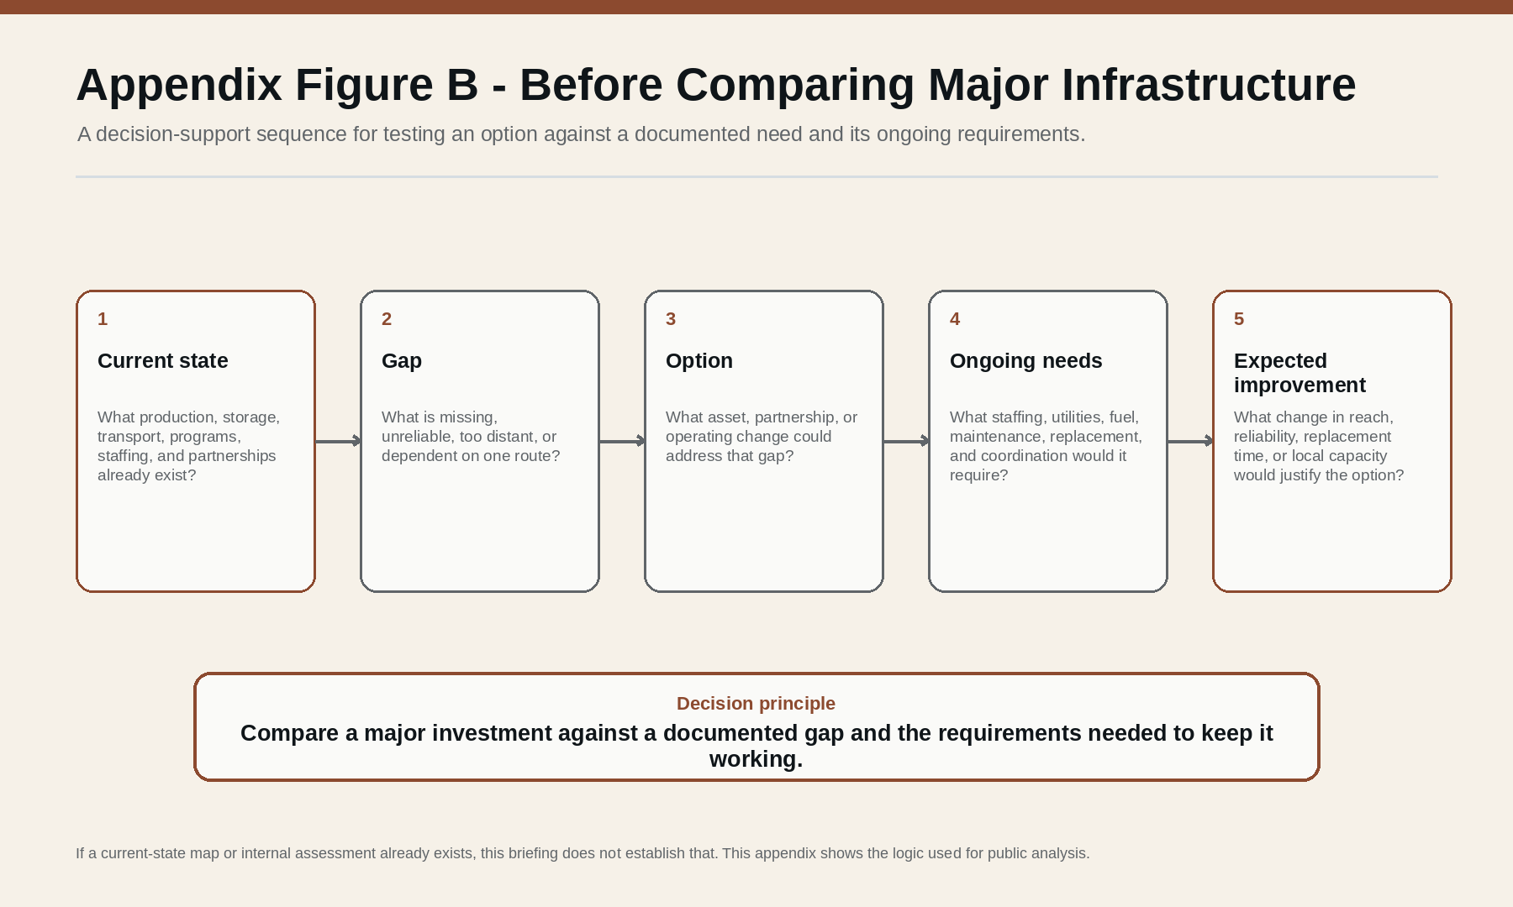
Appendix Figure B. Before Comparing Major Infrastructure. A decision-support sequence: current state, gap, option, ongoing needs, and expected improvement. Analytical only; not a Tribal decision rule.
Decision test | Question | Evidence needed
Demonstrated need | What specific failure, bottleneck or service gap would this option address? | Current-state map; service/output evidence
Existing capacity | What usable production, storage, vehicles, staffing or partnerships already exist? | Current Reality Audit
Capital requirement | What one-time acquisition, construction or rehabilitation cost is required? | Defined scope and capital estimate
Ongoing operating requirements | What annual utilities, fuel, insurance, staffing, software, supplies or other operating costs follow? | Operating-cost estimate
Maintenance and replacement | What upkeep, replacement cycle, repair capability and reserve are required? | Lifecycle/maintenance plan
People and skills | Who will operate it, and what staffing, training, certification or coverage is required? | Workforce plan
Funding continuity | Is funding one-time, restricted, grant-dependent or renewable? What happens when it ends? | Funding terms and continuation plan
Dependencies and contingency | What external inputs, vendors, roads, power, water, parts or permissions could stop it? | Dependency/failure-point analysis
Coordination and authority | Who is responsible for operation, purchasing, scheduling, data, partnerships and decisions? | Publicly appropriate responsibility map
Expected reliability improvement | What changes if the option works - reach, reserve days, replacement-supply time, local sourcing, reliability or another defined measure? | Baseline + target + review date

Planning should define the capital need. A capital award does not erase staffing, utilities, maintenance, replacement, dependency or contingency costs.

Appendix F - Detailed Decision Checks
Complex food-system investments can appear sound through one lens and fail through another. The first table checks operational structure, people, coordination/interests and community purpose. The second asks whether the option addresses a demonstrated need, fits the larger system, and keeps authority and public-purpose boundaries clear.
Lens | Public decision question
Operations and structure | Does the option close an evidenced logistics gap? How does it connect to production, storage, routes, schedules, information and backup supply?
People and workforce | Who must operate and maintain it? Are staffing, training, safety, workload and continuity realistic?
Coordination and interests | Which programs, funders, vendors, partners and decision-makers must cooperate? Where could scarce resources or competing priorities create friction?
Community purpose and authority boundaries | Does the option remain connected to the stated public purpose? Are its status, limits, responsibilities, privacy boundaries and expected benefits understandable to members?

Check | Question
Relevance | Does the proposed action answer a demonstrated present or foreseeable need rather than merely fit an available funding opportunity?
Coherence | Do production, logistics, staffing, finance, authority, dependencies and measurement fit together as one workable system?
Authority and public-purpose fit | Are authority, source status, community purpose, privacy limits, participation and the distinction between proposal and accomplishment kept clear?

These are public analytical prompts. They are not an official Tribal governance framework and do not prescribe who must decide. Their purpose is to expose dependencies and prevent a technically attractive option from being mistaken for a complete solution.

Appendix G - Program and Policy Watch

G.1 FDPIR national distribution resilience
USDA documented 2024 FDPIR/CSFP delivery disruptions tied to a contracted national warehouse and later reported regular scheduled deliveries restored by October 28, 2024. [R14] Status: historical disruption documented; immediate 2024 disruption reported resolved.

G.2 FDPIR Self-Determination Demonstration
The demonstration allows selected Tribal organizations to procure certain replacement foods themselves and use Tribal/regional vendors. [R15] [R16] Status: existing federal demonstration; not an automatically available Pit River program.

G.3 FDPIR Tribal Food Sovereignty Act of 2026
S. 4785 was introduced June 15, 2026 and was listed in the public record checked for this briefing at the introduced/referred stage. [R17] Status: pending legislation, not current law.

G.4 Transformative Climate Communities Round 6
The Pit River newsletter identifies greenhouse resilience improvements as proposed and not yet funded or confirmed. TCC Round 6 is application-stage with a September 30, 2026 final-application deadline. [R1] [R18]

G.5 Community Resilience Centers Round 2
The newsletter identifies a proposed approximately $10 million Community Resilience Center and says the proposals are not yet funded or confirmed. CRC Round 2 is application-stage. [R1] [R19]

Appendix H - Figure Register and Evidence Status
Figure 1 - How Food Reaches a Household
Food moves through several physical steps, while temperature control and information can support more than one part of the chain. Illustrative only; not a map of current Pit River routes, services, or household travel.
Figure 2 - Why Distance Can Make Food Delivery Harder
Longer routes, lower delivery density, longer cold-chain exposure, and distant replacement supply can increase delivery cost and disruption exposure. Conceptual; not actual Pit River freight data.
Figure 3 - Three Questions for a More Resilient Food System
Three parallel questions about current access, physical reliability, and where greater Tribal control could help. This is not a complete definition of food sovereignty or a statement of Tribal policy.
Figure 4 - Documented and Potential Food-System Connections
A bounded network view separating documented relationships, developing or expected relationships, and potential connections not established in the public sources reviewed.
Appendix Figure A - Current Reality Information Audit
The 25 evidence questions grouped by domain. Counts show how the audit is organized, not project performance, importance, or deficiency.
Appendix Figure B - Before Comparing Major Infrastructure
A decision-support sequence: current state, gap, option, ongoing needs, and expected improvement. Analytical only; not a Tribal decision rule.

Appendix I - Source-Control, Corrections and Standing Review Trigger
A material new source should not automatically change the briefing. It triggers review of the affected claim, evidence status, finding and version decision.
NEW INFORMATION -> SOURCE CHECK -> CLAIMS AFFECTED -> EVIDENCE-STATUS CHANGE? -> FINDING CHANGE? -> VERSION / CORRECTION DECISION

Standing review trigger
- greenhouse production, harvest volume, seasonality, operating capacity or distribution;
- food-distribution routes, storage, transportation, emergency supply or other food-system infrastructure;
- TCC greenhouse proposal status, application disposition, award, scope, funding amount or implementation;
- Community Resilience Center proposal status, award, scope, funding or implementation;
- Humisoil curing, production volume, use, plant-production outcomes or project completion;
- FDPIR distribution, Tribal self-determination authority, procurement policy, funding or legislation;
- employment, training, revenue, market relationships or other outcome measures in the Projection-to-Reality ledger;
- newly released Tribal reports, newsletters, grant documents, evaluations, project updates or other authoritative public records;
- or a credible factual correction to the current briefing.
Materiality rule: new information is material when it changes what the briefing can responsibly say about present conditions, past performance, projected outcomes, funding or implementation status, or a principal finding.

Correction format
- Previous wording or finding
- Corrected wording or finding
- Reason for change
- New evidence
- Checked date
- Effect on the briefing's conclusions
Version rule: no substantive change -> log/recheck only; minor factual correction -> correction entry; material evidence change -> new briefing version; major project or policy change -> rerun the Projection-to-Reality pass.

Appendix J - Current Bottom-Line Findings
Finding 1. Food logistics is a legitimate food-access issue in geographically dispersed rural communities. Distance, routing, storage, transportation and cold-chain requirements affect whether food reaches households reliably.
Finding 2. The 2024 federal FDPIR/CSFP delivery disruption demonstrated a real vulnerability in centralized distribution, even though USDA later reported the immediate disruption resolved. [R14]
Finding 3. Greenhouse redevelopment activity is documented. Public sources reviewed for this briefing describe restoration, grants, staffing and additional project development. [R2] [R8] [R10] [R11]
Finding 4. The greenhouse's full current production and distribution capacity is not established in the public sources reviewed for this briefing.
Finding 5. The Humisoil project has crossed from projection into documented physical output: the Tribe reports the first batch has been produced. The 100,000+ plants remain prospective. [R1]
Finding 6. The Tribe itself now publicly identifies vulnerable external food supply chains as a resilience concern, while clearly labeling the proposed greenhouse upgrades as not yet funded or confirmed. [R1]
Finding 7. Several related capacities are visible and could complement one another, but their operating connections are not fully established in the public sources reviewed.
Finding 8. The public sources reviewed are not sufficient to compare a specific major logistics investment responsibly before the current system and its actual bottlenecks are better established.
Finding 9. The appropriate public posture is neither success declaration nor failure declaration: implementation is documented, some intermediate outputs are documented, and several ultimate food-access, economic and resilience outcomes remain prospective or insufficiently measured.

References
Reference-use note: R1-R26 are evidence or contextual sources used to support factual or domain claims. R27-R31 are method and presentation sources used to improve organization, decision analysis and visual communication. The methods sources do not establish Pit River conditions. Project, funder, and technical-assistance profiles - including R9 and R13 - are used for reported project characteristics, stated objectives, and historical expectations; they are not treated as independent verification that those outcomes were achieved.

Evidence and contextual sources
[R1] Pit River Tribe. 2026. Newsletter - Quarter 3, August 2026. Official Tribal newsletter supplied directly to The Long Return. Key pages: Humisoil Production Project Update (p. 2); Call for Feedback on proposed Transformative Climate Communities greenhouse improvements and Community Resilience Center (p. 4).
[R2] Pit River Tribe. 2025. Newsletter - Quarter 4, November 2025. Reports greenhouse restoration after years of dormancy, First Nations grants, staffing/equipment support, and the 10-acre Alturas greenhouse site. Source
[R3] Pit River Tribe. 2005 revision. Constitution of the Pit River Tribe. Public constitutional text used for the four-county / 100-mile-square geography context. Source
[R4] Pit River Tribe. current page checked Aug. 20, 2026. Social Services. Public assistance doorway; includes food and other support information and a Hoopa Food Distribution Program application. Source
[R5] Pit River Tribe. 2024. Request for Proposals: Feasibility Study for Photovoltaic and Battery Energy Storage Systems at XL Ranch and Burney Tribal Lands. Energy-resilience planning relevant to greenhouse and emergency continuity. Source
[R6] Pit River Tribal Office. 2025. Partnership Coordinator - Position Description. Temporary grant-funded role associated with greenhouse/Humisoil partnership development and food-sovereignty work. Source
[R7] Pit River Tribal Office. 2026. Native Plant Specialist - Position Description. Temporary grant-funded greenhouse role involving propagation, restoration, native/traditional plants, inventory, and Humisoil. Source
[R8] Sierra Institute for Community and Environment / Pit River Tribe. 2024. High Road Training Partnership Apprenticeship. Workforce-development activity associated with greenhouse development, restoration and Tribal capacity. Source
[R9] First Nations Development Institute. 2025. Green Economies: Advancing Native American Economies and Workforce Development Report. Historical project framing for greenhouse scale, food distribution goals, employment projections, training, native plants, energy, and possible revenue pathways. Source
[R10] First Nations Development Institute. 2025. Native Agriculture and Food Systems Investments - Pit River Greenhouse. Records a $30,000 food-systems investment for the Pit River Greenhouse. Source
[R11] First Nations Development Institute. 2025. Stewarding Native Lands - Pit River Native Plant Greenhouse Phase II. Records a $50,000 award supporting food sovereignty and ecological stewardship capacity. Source
[R12] North State Planning and Development Collective / California Jobs First. 2025-2026. Catalyst Projects - Good Jobs Pit River Tribe Greenhouse Complex. Records a $296,000 Catalyst award for Humisoil production from invasive juniper biomass and related workforce/ecological goals. Source
[R13] California Office of the Small Business Advocate. Aug. 4, 2025. The Pit River Greenhouse Project: Cultivating a Path to Food Sovereignty. Describes project activity, market intentions, and reports 25 jobs supported with plans for at least 35; employment terminology is not treated as equivalent to permanent FTEs. Source
[R14] U.S. Department of Agriculture, Food and Nutrition Service. 2024. FDPIR and CSFP Supply Chain Disruptions. Documents warehouse-related delivery disruption, emergency measures, added warehouse capacity, and USDA's report that regular scheduled deliveries were restored by Oct. 28, 2024. Source
[R15] U.S. Department of Agriculture, Food and Nutrition Service. updated 2026. FDPIR Self-Determination Demonstration Project. Describes Tribal procurement authority within the demonstration and examples of Tribal/regional food purchasing. Source
[R16] U.S. Department of Agriculture, Food and Nutrition Service. Mar. 13, 2026. Report on the Food Distribution Program on Indian Reservations (FDPIR): Demonstration Project for Tribal Organizations. Congressionally mandated report on FDPIR self-determination contracts and Tribally procured foods. Source
[R17] U.S. Congress / GovInfo. 2026. S. 4785 - FDPIR Tribal Food Sovereignty Act of 2026. Introduced June 15, 2026; public record checked for this briefing listed the measure at the introduced/referred stage. Source
[R18] California Strategic Growth Council. 2026. Transformative Climate Communities Program - Funding Round 6 Notice of Funding Availability. Application-stage state program relevant to the proposed greenhouse resilience improvements; final applications due Sept. 30, 2026. Source
[R19] California Strategic Growth Council. 2026. Community Resilience Centers - Round 2 application materials and timeline. Application-stage program relevant to the proposed Community Resilience Center; implementation applications due Sept. 25, 2026, with awards expected in 2027. Source
[R20] Jonah Rogoff. 2014. Improving Systems of Distribution and Logistics for Regional Food Hubs. Central Appalachian Network / MIT Wealth Creation Clinic report on rural food-hub distribution, routing, transportation partnerships, anchor buyers and asset management. Source
[R21] Samir Dani. 2015. Food Supply Chain Management and Logistics: From Farm to Fork. Kogan Page. Used for logistics infrastructure, safe storage, transport, temperature-controlled distribution and supply-chain resilience concepts. Source
[R22] Carlos Mena and Graham Stevens, eds.. 2010. Delivering Performance in Food Supply Chains. Woodhead Publishing. Supporting literature on food-supply-chain performance, uncertainty, relationships and distribution. Source
[R23] Jennifer Sowerwine, Megan Mucioki, Daniel Sarna-Wojcicki, and Lisa Hillman. 2019. Reframing Food Security by and for Native American Communities: A Case Study among Tribes in the Klamath River Basin of Oregon and California. Food Security 11(3):579-607. Regional Indigenous food-security context; not a Pit River household survey. Source
[R24] Megan Mucioki, Jennifer Sowerwine, and Daniel Sarna-Wojcicki. 2018. Thinking Inside and Outside the Box: Local and National Considerations of the Food Distribution Program on Indian Reservations (FDPIR). Journal of Rural Studies 57:88-98. Background on FDPIR in Native food systems. Source
[R25] Jennifer Sowerwine et al.. 2019. Enhancing Indigenous Food Sovereignty: A Five-Year Collaborative Tribal-University Research and Extension Project in California and Oregon. Journal of Agriculture, Food Systems, and Community Development. Broader Indigenous food-sovereignty context; not evidence of current Pit River conditions. Source
[R26] National Institute on Minority Health and Health Disparities. 2023 estimates. HDPulse Data Portal - Food Insecurity, California counties. County-level context reviewed for Modoc, Siskiyou, Shasta and Lassen Counties. County estimates are not Pit River-specific household rates. Source

Methods and presentation references
[R27] Barbara Minto. rev. ed.. The Pyramid Principle: Logic in Writing and Thinking. Method and presentation reference. Used to place the governing answer before supporting detail, group like ideas, and keep argument order explicit. This source does not establish Pit River facts.
[R28] John Bowden. 2nd ed., 1994. How to Write a Report: A Step-by-Step Guide to Effective Report-Writing. Method and presentation reference. Used for executive-summary discipline, reader-centered structure, warranted conclusions, and controlled use of appendices and illustrations. This source does not establish Pit River facts.
[R29] Jason Lankow, Josh Ritchie, and Ross Crooks. 2012. Infographics: The Power of Visual Storytelling. Method and presentation reference. Used to test figures for utility, soundness, and design appropriateness to the information and audience. This source does not establish Pit River facts.
[R30] Margaret J. Barr and George S. McClellan. 2011. Budgets and Financial Management in Higher Education. Method and decision-design reference. Used to distinguish capital from operating costs, test hidden and recurring costs, link planning to capital decisions, and use scenarios. This source does not establish Pit River facts.
[R31] Lee G. Bolman and Terrence E. Deal. 7th ed., 2021. Reframing Organizations: Artistry, Choice, and Leadership. Method and decision-design reference. Used to examine operational structure, people/workforce, coordination and interests, and community meaning through multiple lenses. This source does not establish Pit River facts.
Public working briefing · Pass with material open questions
Christopher Knorr | The Long Return
Independent civic work - not an official Pit River Tribe publication or notice.

