Agency, Recognition, and the Conditions of Freedom
A Structural Framework
Working paper — analytic pole of the trilogy
Zero draft

Abstract
This paper states and defends a structural framework for understanding individual and collective agency under conditions of domination. Against the liberal picture of agency as a capacity exercised by an antecedently constituted individual, it argues that agency is constituted relationally; that effective freedom is a bounded function of accumulated enabling conditions and exposure to violence rather than a possession conferred by formal liberty; that recognition is prior to the agent's self-presentation and is morally ambivalent rather than a good to be secured; that institutions can preserve their outward form while losing their function, in a manner that is behaviorally detectable; that uncorrected misrecognition exhibits a hardening dynamic that converts an event first into a structure and then into a feature of the subject; and that refusal is a genuine exercise of agency even when it is non-efficacious, because it withholds the consent that converts force into authority. The framework is positioned against the capabilities approach, recognition theory, theories of institutional capture and legibility, and standpoint epistemology, with which it variously converges and from which it departs. Three figures render the load-bearing claims as formal structures. The paper closes by stating the strongest objections to the framework and responding to them.

1. Introduction
Theories of freedom and agency tend to begin from the case in which agency is least in question. They take as their model a person who is already secure — already recognized, already possessed of standing, already situated where the conditions of action obtain — and ask what further liberty such a person requires. This produces accounts well suited to describing the marginal freedoms of the already-free and poorly suited to describing the situation of those for whom recognition, standing, and the conditions of action are precisely what is in dispute. The framework set out here begins from the opposite case. It takes as its model the agent under domination — seen wrongly or not at all, processed by institutions built to other ends, formally at liberty while materially unfree — and asks what agency is, given that case.
The wager of the paper is that the dominated case is not a degenerate instance of agency to be handled after the central theory is built, but the case from which the central theory is best built, because it makes visible structural features that the secure case conceals. What looks, from the position of the secure, like the natural backdrop of free action — recognition, standing, enabling conditions — is revealed, from the position of the dominated, as a contingent and unequally distributed substrate whose presence or absence determines whether formal liberty amounts to anything at all. The framework is, in this sense, a theory of the substrate of agency, developed from the standpoint of those for whom the substrate has been attacked.
Here the framework stands on argument alone. It is stated as a set of propositions, each motivated, positioned against the relevant literature, and defended; the load-bearing claims are rendered as formal structures in three figures; and the strongest objections are stated and answered in the final section.

2. The relational constitution of agency
Proposition 1. Agency is constituted in relation, not in isolation. The relations that situate an agent — to other persons, to a community, to a place, to a tradition handed forward — are not external constraints upon an antecedently constituted agency but the conditions of its constitution.
The dominant liberal picture treats the individual as the primitive term and relations as supervening upon it: first there is an agent with preferences and a will, and then there are the social relations into which that agent enters, which may enable or constrain but do not constitute. On this view, to expand freedom is to remove interference, and other persons appear chiefly as potential interferers. The picture has the merit of clarity and the defect of getting the order of constitution backwards.
It departs from them in locating the relational constitution not only in the conditions of capability but in the very identity of the agent, whose self is held in relation and not behind it.

3. Effective freedom as a bounded condition
Proposition 2. Effective freedom is a function of accumulated enabling conditions and of exposure to violence. Formal liberty without the enabling substrate, or under sufficient exposure to violence, is not effective freedom; it is the name of a freedom that does not obtain.
If agency is relationally constituted, then freedom cannot be the mere absence of interference, because the absence of interference does nothing for an agent whose constitutive conditions have been destroyed. The framework replaces the on/off picture of liberty with a graded one. An agent's effective freedom rises with the enabling conditions accumulated over a life — material, relational, epistemic, and institutional — and falls with exposure to violence, where violence is understood broadly as the severe violation of agency across the layers of a person's holdings. Freedom, on this account, occupies a bounded region of the space defined by these two variables, rather than naming a status a person either has or lacks (Figure 1).
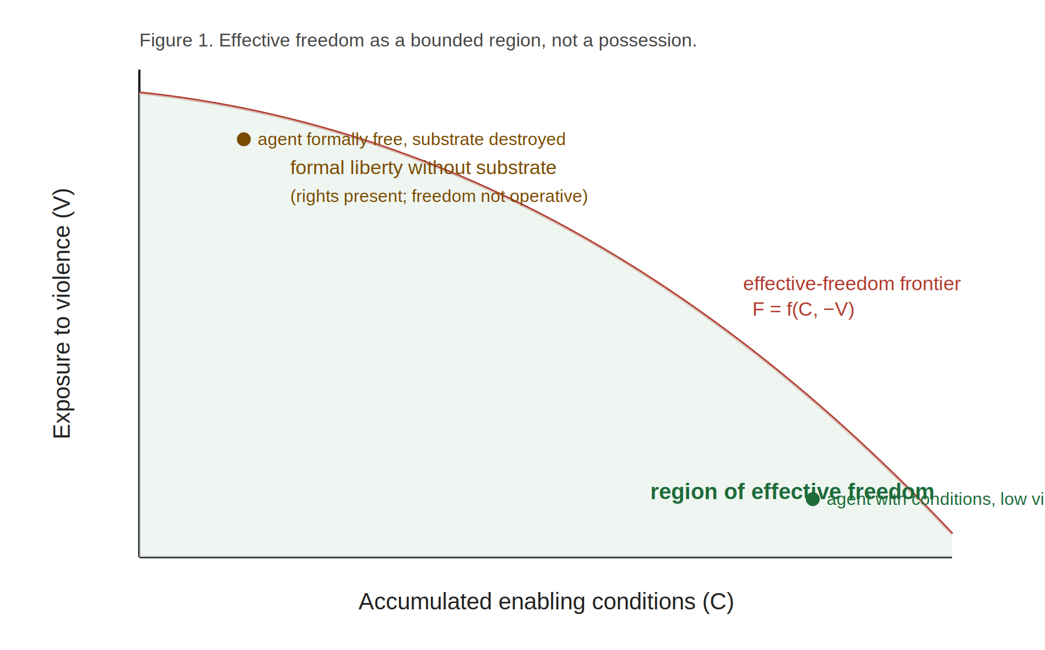
The practical consequence is the gap between formal liberty and effective freedom. A legal order can extend identical formal liberties to all while the substrate that would make those liberties operative is present for some and destroyed for others. For the agent whose enabling conditions have been dismantled and whose exposure to violence is high, the formal liberty is real as a matter of law and empty as a matter of agency. This is not hypocrisy in the legal order; the liberty is genuinely extended. It is a category error in the theory of freedom, which mistakes the extension of liberty for the obtaining of freedom. The framework's account of the substrate is what lets the error be named.
This proposition invites the charge of determinism, addressed in section 8. Stated here is only its positive content: that freedom is conditioned, that the conditions are unequally distributed, and that a theory which assesses freedom without reference to the conditions will systematically misdescribe the freedom of the unconditioned as though it were the freedom of the conditioned.

4. The priority and ambivalence of recognition
Proposition 3. Recognition is prior to the agent's self-presentation. A person is recognized into a category before they present themselves, and they act thereafter against a description already in place.
Proposition 4. Recognition is morally ambivalent. It can protect or it can dominate; it is not, as such, a good to be secured, and the demand for recognition is therefore not self-justifying.
The framework accepts the centrality and contests the valuation. It makes two claims the tradition tends to underweight. The first is temporal and logical priority: recognition is not a response to an agent who has presented themselves but a prior operation that frames the field within which any self-presentation will be read. The agent does not appear and then get recognized; the recognition is already in place, and the agent contends with it (Figure 2).
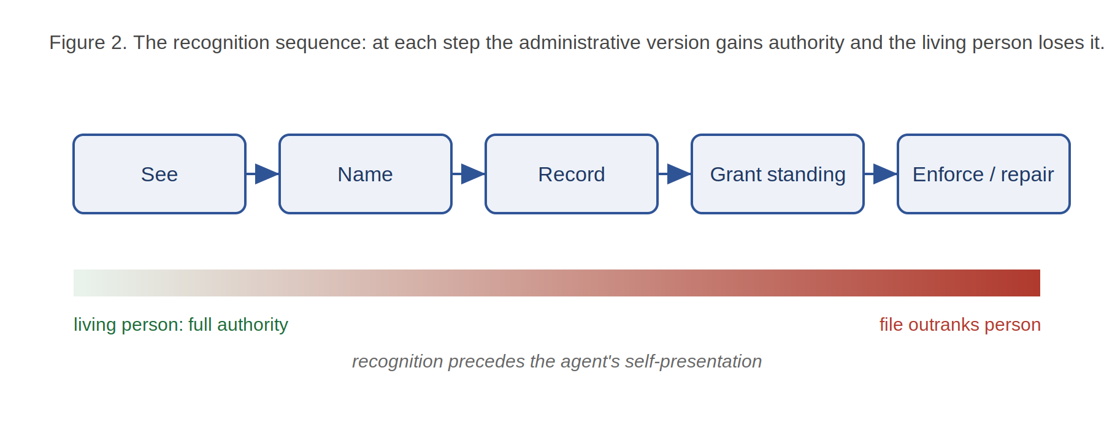

5. Preserved form: the divergence of form and function
Proposition 5. An institution can retain its outward form while losing the function the form exists to serve, and the divergence is behaviorally detectable. An institution exhibits preserved form when use of its recognized channel, correctly performed, reliably fails to alter the contested outcome the institution exists to determine — and when lifting the resource constraint does not restore the outcome.
Institutions present a form — offices, procedures, courtesies, records — and exist to perform a function — to protect, adjudicate, provide, or repair. In a functioning institution the form serves the function. The two can nonetheless come apart, such that the form is fully maintained while the function has been withdrawn. From the outside, and from the front desk, a captured institution of this kind is indistinguishable from a functioning one: the procedures are observed, the staff sincere, the records complete. The framework supplies a test that does not depend on any of these (Figure 3).
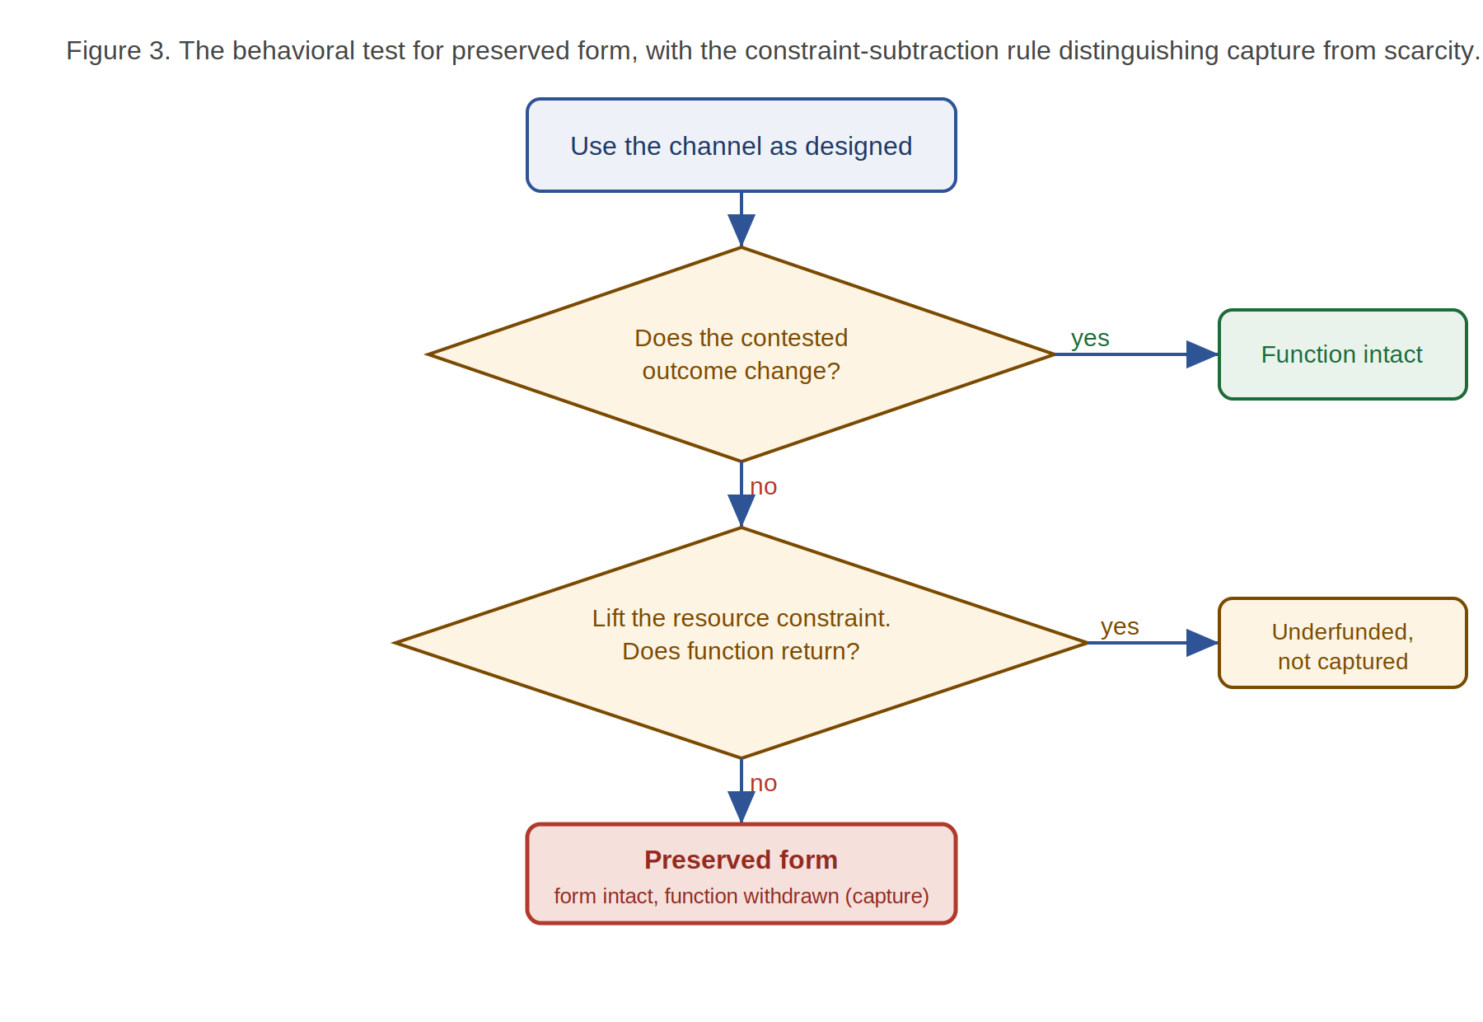

6. The hardening of uncorrected misrecognition
Proposition 6. Uncorrected misrecognition hardens over time: an event becomes, through repetition without repair, first a structure and then a feature attributed to the subject. The attribution of the injury to the nature of the injured is the terminal stage of the dynamic, not a finding about the injured.
A misrecognition that is corrected remains an event in a life. One that is never corrected does not hold still. Through repetition, and through the accumulation of arrangements that presuppose it, the misrecognition becomes load-bearing: more rests upon it, more of the surrounding order assumes it, and naming it as a wrong comes to require unsettling everything built atop it. At this stage it has become a structure, experienced no longer as something done to anyone but as the neutral way things are. The wrong has been laundered, by duration and repetition, into circumstance.
The framework adds a further stage that an external analysis can miss: the same dynamic can continue inward, so that the structure becomes a feature attributed to the subject. The diminished reaching of a person long misrecognized comes to be read — by others, and sometimes by the person — as their nature, their temperament, their limit. This attribution is the terminal stage of the hardening, and the framework's claim about it is precise: it is a stage of an injury with a history, not a true finding about the injured. The analytic stakes are high, because an analysis conducted from outside is liable to record the terminal stage as a trait of a population and thereby to reproduce, in a scholarly register, the very misrecognition it should expose. Naming the dynamic as a dynamic is what denatures the attribution and restores its status as injury.

7. Refusal as non-efficacious agency
Proposition 7. Refusal is a genuine exercise of agency even when it cannot secure its aim, because it withholds the consent that converts force into authority. A standing refusal, held collectively and handed forward, constitutes a form of agency that persists across generations and that no application of force can directly extinguish.
If agency is measured solely by efficacy — by whether an act secures its aim — then refusal that does not prevail is not agency but futile gesture. The framework rejects the efficacy measure as the sole criterion. It distinguishes what force can and cannot do: force can compel a body, seize a thing, occupy a territory; it cannot, by itself, produce the consent that would convert its exercise from imposition into authority. That consent is the one thing the dominated retain the power to withhold, and withholding it is an exercise of agency that operates independently of efficacy. The refusal keeps the question of legitimacy open; it denies the dominating order the conversion of conquest into title; and it thereby interrupts the hardening dynamic of section 6, which depends on the eventual supply of consent, whether active or resigned.
At the collective scale the point sharpens. A people that has never validly consented to a dispossession retains, across generations, the standing to refuse it again, because the refusal was never spent. This is why dominating orders expend effort to manufacture the appearance of consent even where they could proceed by force alone: the appearance of agreement is what force cannot supply and what converts an imposition into an accepted order. The framework's account of refusal is, in this respect, an account of why consent is valuable to power and therefore of why its withholding is a genuine exercise of agency. The claim is carefully bounded: refusal is not held to guarantee outcomes, and the framework does not maintain that refusal protects the refuser from harm. It maintains only that refusal is an act, not the absence of one, and that its reality does not depend on its success.

8. Objections and responses

8.1 That the relational thesis dissolves individual responsibility
If agency is constituted relationally and freedom is conditioned by an unequally distributed substrate, it may seem to follow that individuals cannot be held responsible for their actions, since the conditions of their agency lie partly outside them. The response distinguishes constitution from determination. To say that agency is relationally constituted is to say that the relations are part of what makes an agent an agent; it is not to say that the constituted agent does not then act, or that their actions are not theirs. A relationally constituted agent is still an agent and still acts; responsibility attaches to the agency the relations constitute, not to a fictional unconditioned will. What the framework denies is only the attribution of outcomes to individual will alone where the conditions of agency were themselves destroyed — which is not the dissolution of responsibility but its correct allocation.

8.2 That the freedom equation is deterministic
If effective freedom is a function of conditions and exposure to violence, freedom may appear to be determined by circumstance, leaving no room for the agency the framework elsewhere insists upon. The response notes that the proposition states a bounding relation, not a determining one. Conditions and violence set the region within which effective freedom obtains; they do not fix a point within it. The entire burden of the companion phenomenology, and of the propositions on refusal and repair here, is that agency operates within the bounded region, often at its very edge, and sometimes acts to enlarge the region for others. The equation describes the field of action, not its replacement.

8.3 That recognition-ambivalence collapses into a rejection of recognition
If recognition can dominate as readily as protect, one might conclude that the framework counsels the refusal of recognition altogether. It does not. The claim is that recognition is ambivalent and that its value is therefore conditional on the apparatus performing it — not that recognition is to be refused, which would forfeit the protections recognition by a benign apparatus secures. The framework counsels not the rejection of recognition but the interrogation of it: by whom, on whose terms, to what use. This is a more demanding position than either the pursuit or the refusal of recognition, and it is the position the ambivalence thesis actually entails.

8.4 That refusal-as-agency romanticizes powerlessness
To call non-efficacious refusal a genuine exercise of agency may seem to dignify defeat — to offer the dominated the consolation of a moral victory in place of the substance of a material one. The response turns on the bounded character of the claim. The framework does not hold that refusal suffices, or that it protects, or that it should be preferred to efficacious action where the latter is available. It holds only that refusal is an act and not the absence of one, and that a theory measuring agency by efficacy alone will misclassify a real exercise of agency as a non-event. This is a claim about the correct description of refusal, not a recommendation to prefer it; the recommendation, where efficacious action is possible, is for efficacious action. What the framework refuses is the further claim that the dominated, when they cannot prevail, are therefore not acting.

9. Conclusion
The framework set out here is a theory of the substrate of agency, built from the case of the agent under domination because that case makes the substrate visible. Its propositions form a connected account: agency is relationally constituted (P1); effective freedom is the bounded condition that this constitution, under exposure to violence, permits (P2); recognition is the prior and ambivalent operation through which an agent is taken into the systems that condition them (P3, P4); those systems can preserve their form while withdrawing their function, detectably (P5); uncorrected misrecognition hardens from event to structure to attributed trait (P6); and refusal is the exercise of agency that withholds the consent on which the hardening and the conversion of force into authority both depend (P7). The account converges with the capabilities approach, with relational autonomy theory, with the analysis of legibility, and with standpoint epistemology, and departs from recognition theory in treating recognition as ambivalent rather than as a good. The companion works develop the same framework as lived standpoint and as family memory; this paper has aimed to show that it stands, as well, as argument.

This paper is the third pole of a trilogy. The companion phenomenology develops the same framework from a first-person standpoint anchored in a single life; the third work treats that life as family memory. The present paper stands on argument alone and makes no use of the biographical material that anchors the other two. The division is deliberate: the three works know the same framework by different means — argument, standpoint, and memory — and none is reducible to the others.
Amartya Sen, Development as Freedom (Oxford: Oxford University Press, 1999); Martha Nussbaum, Women and Human Development (Cambridge: Cambridge University Press, 2000). On relational autonomy, see Catriona Mackenzie and Natalie Stoljar, eds., Relational Autonomy (Oxford: Oxford University Press, 2000).
Axel Honneth, The Struggle for Recognition (Cambridge, MA: MIT Press, 1995); Charles Taylor, “The Politics of Recognition,” in Multiculturalism, ed. Amy Gutmann (Princeton: Princeton University Press, 1994); Nancy Fraser and Axel Honneth, Redistribution or Recognition? (London: Verso, 2003).
James C. Scott, Seeing Like a State (New Haven: Yale University Press, 1998).
The behavioral test, the constraint-subtraction rule, and the withdrawal condition correspond to the analytic concept of preserved form developed within the larger corpus to which this paper belongs.

